Judul : Koneksi Database
Nama Kelompok : Salamah Nur Aqidah
Citra Puspita Pebriani
Lestari
Ema Karima Nur’azizah
Afifah Nafis
Program : Tech Muda Batch 4

- Tampilan Web – Tiketku
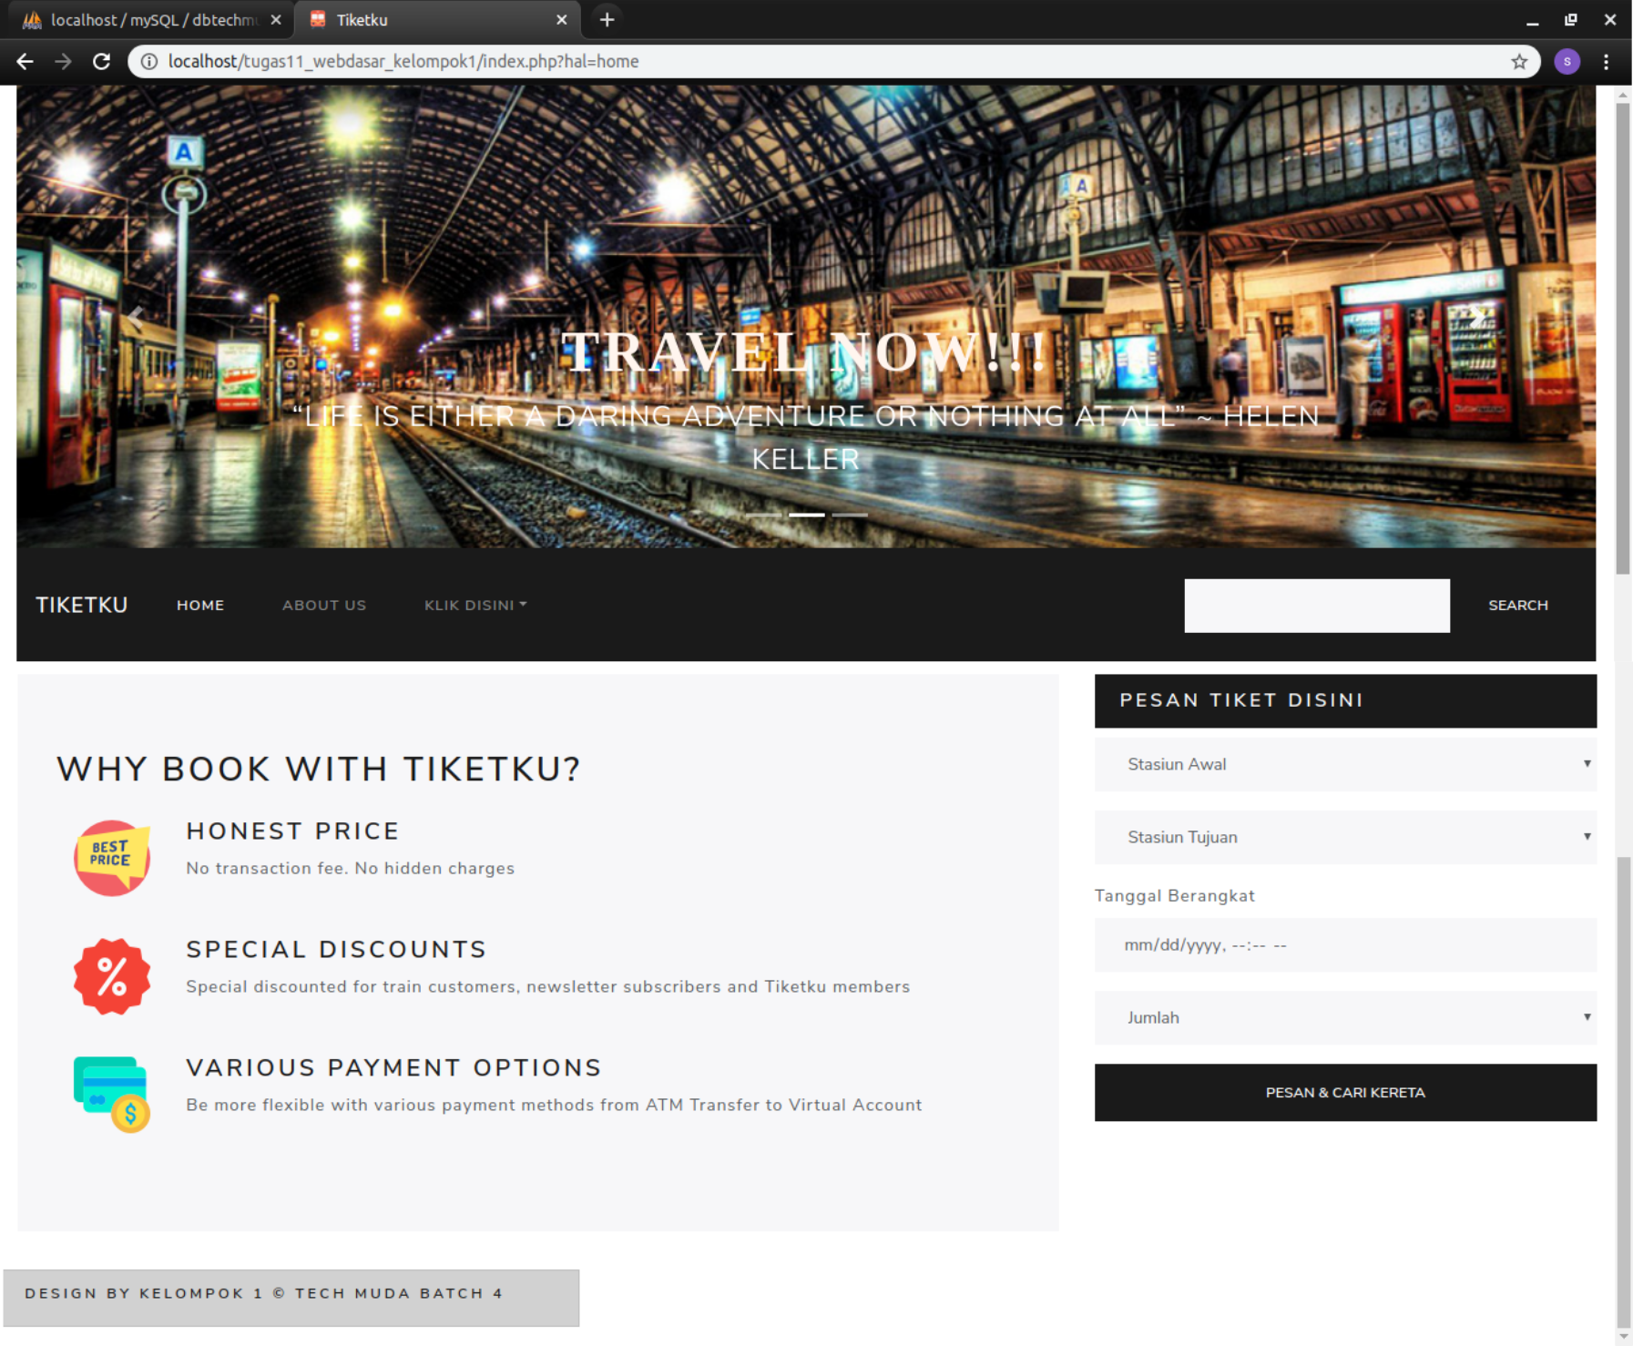
Index.php
<?php
include_once 'koneksi.php';
include_once 'models/Pegawai.php';
include_once 'header.php';
include_once 'menu.php';
echo '<br/>';
include_once 'main.php';
include_once 'sidebar.php';
echo '<br/>';
include_once 'footer.php'

- Tampilan Menu – About Us
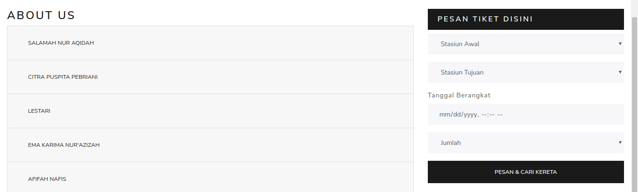
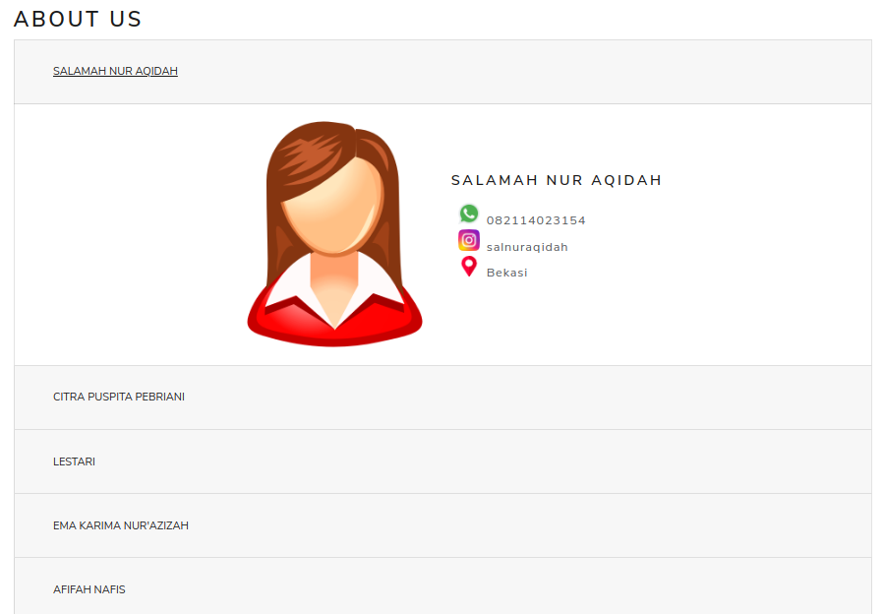
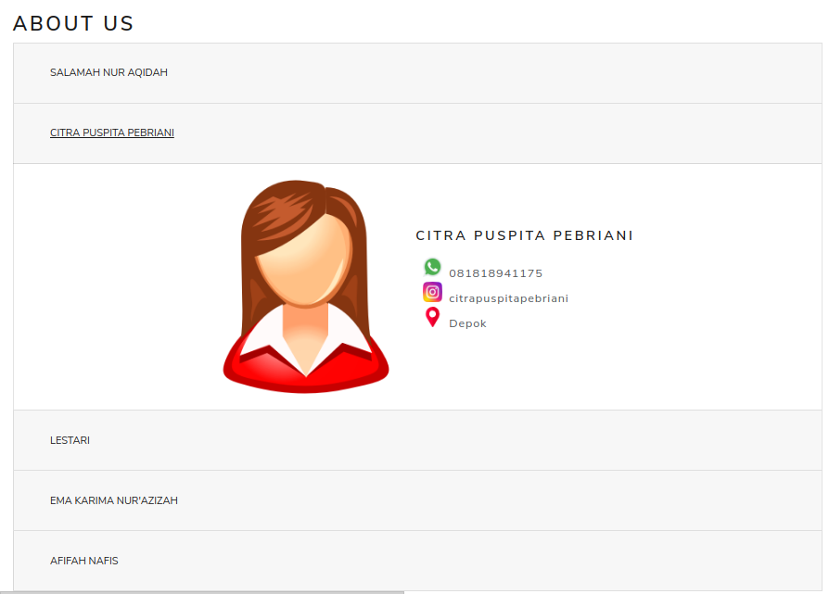

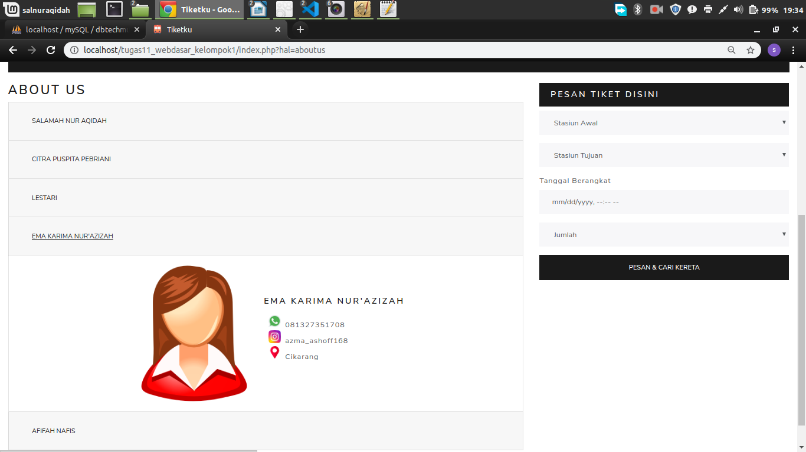
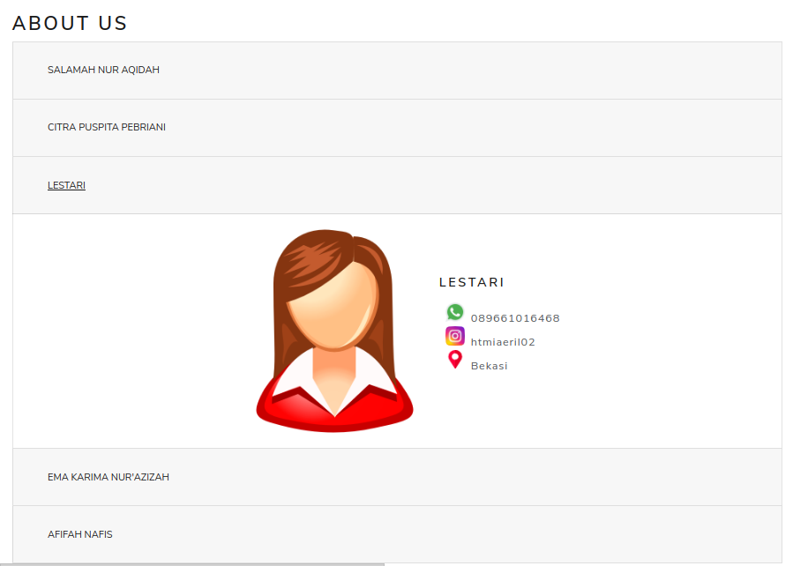

- Koneksi database – Tabel Customer
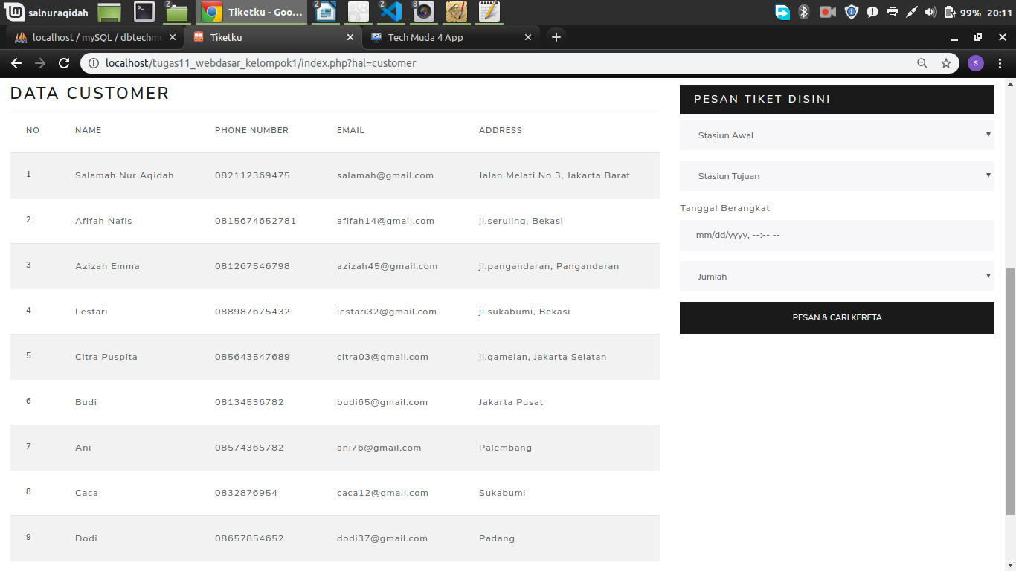
koneksi.php
<?php
/* Connect to a MySQL database using driver invocation */
$dsn = 'mysql:dbname=dbtiketkereta;host=localhost';
$user = 'root';
$password = '';

try {
$dbh = new PDO($dsn, $user, $password);
$dbh->setAttribute(PDO::ATTR_ERRMODE, PDO::ERRMODE_EXCEPTION);
$dbh->setAttribute(PDO::MYSQL_ATTR_USE_BUFFERED_QUERY,TRUE);
} catch (PDOException $e) {
echo 'Connection failed: ' . $e->getMessage();
}
?>

Customer.php
<?php
class Customer{
//member1 var
private $koneksi;
//member2 constructor
public function __construct(){
global $dbh; //panggil var instance pdo
$this->koneksi = $dbh;
}
//member3 fungsi2 crud
public function dataCustomer(){
$sql = "select * from customer";
//prepare statement PDO
$ps = $this->koneksi->prepare($sql); //persiapan
$ps->execute(); //eksekusi
$rs = $ps->fetchAll(); // ambil seluruh baris data
return $rs;
}
};
?>

- Koneksi database – Tabel Order
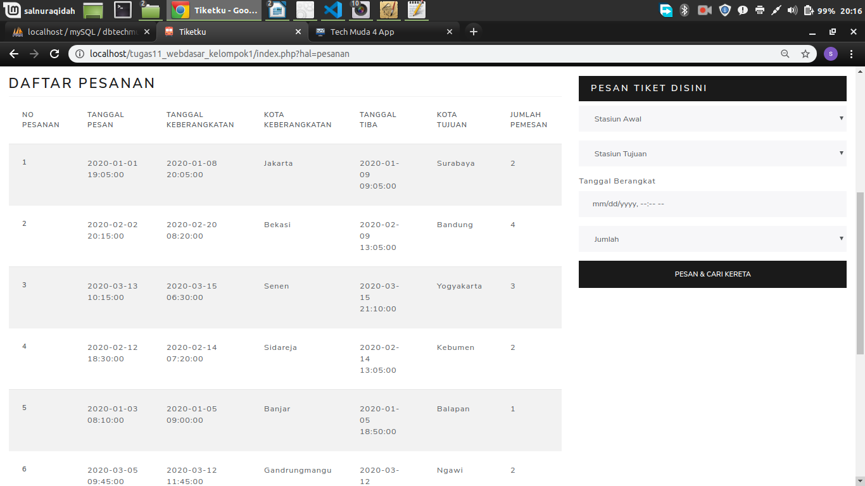

Pesanan.php
<?php
class Pesanan{
//member1 var
private $koneksi;
//member2 constructor
public function __construct(){
global $dbh; //panggil var instance pdo
$this->koneksi = $dbh;
}
//member3 fungsi2 crud
public function dataPesanan(){
$sql = "select * from pesanan";
//prepare statement PDO
$ps = $this->koneksi->prepare($sql); //persiapan
$ps->execute(); //eksekusi
$rs = $ps->fetchAll(); // ambil seluruh baris data
return $rs;
}};?>

- Koneksi database – Tabel Payment
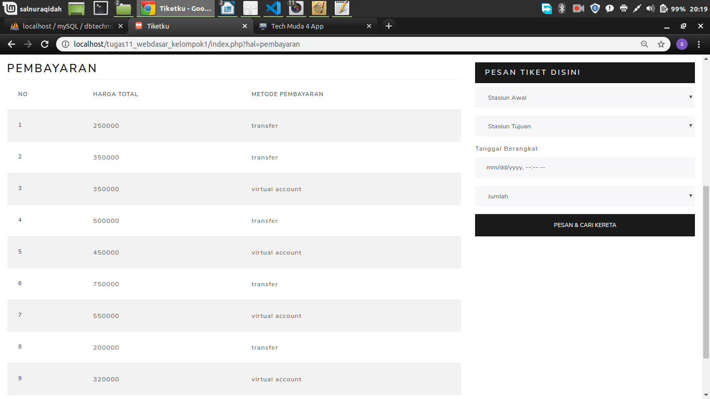
Pembayaran.php
<?php
class Pembayaran{
//member1 var
private $koneksi;
//member2 constructor
public function __construct(){
global $dbh; //panggil var instance pdo
$this->koneksi = $dbh;
}
//member3 fungsi2 crud
public function dataPembayaran(){
$sql = "select * from pembayaran";
//prepare statement PDO
$ps = $this->koneksi->prepare($sql); //persiapan
$ps->execute(); //eksekusi
$rs = $ps->fetchAll(); // ambil seluruh baris data
return $rs;}};?>

